**Implemented Navigation Menu:**



Figure : Navigation Header Menu Bar.

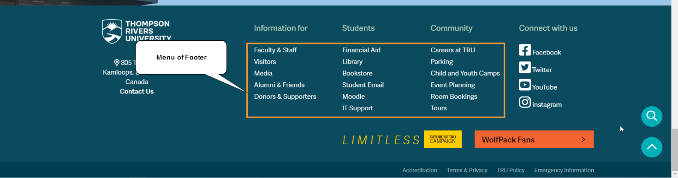

Figure : Footer Menu Bar.



Figure : Menu Bar.

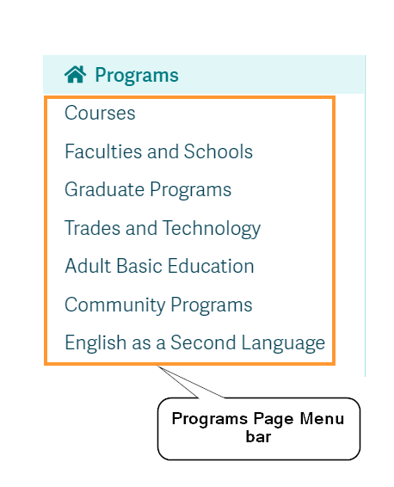

Figure : Program Page Menu Bar.

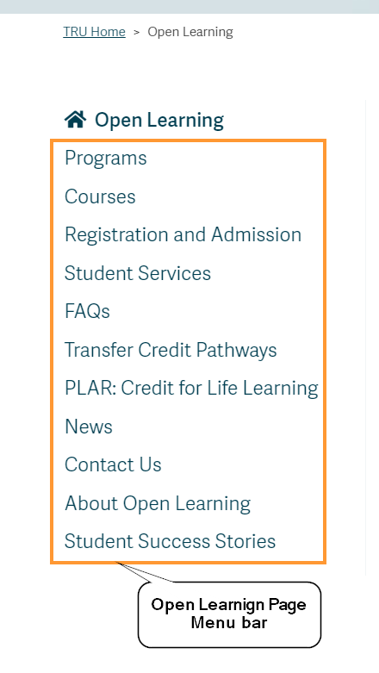

Figure : Open Learning Page Menu Bar.

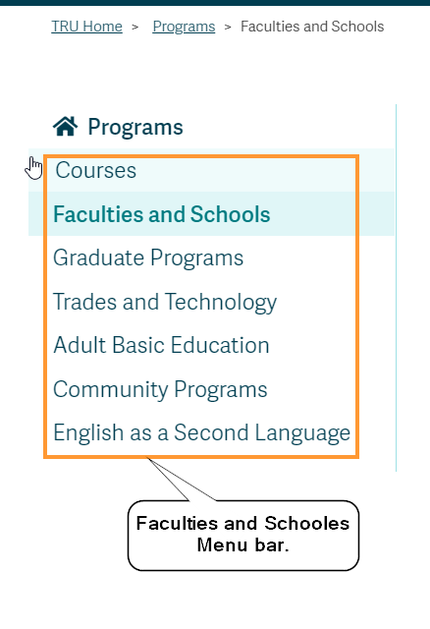

Figure : This is the Faculties and Schools Page Menu Bar.

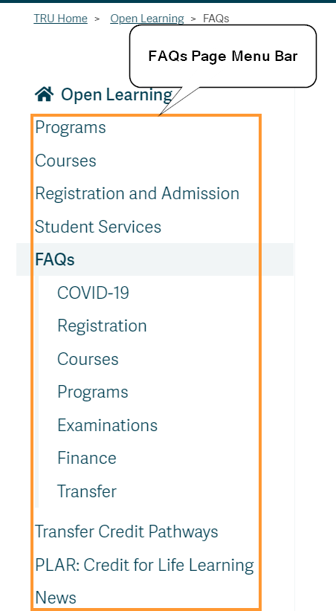

Figure : In this capture show FAQs Page Menu Bar.

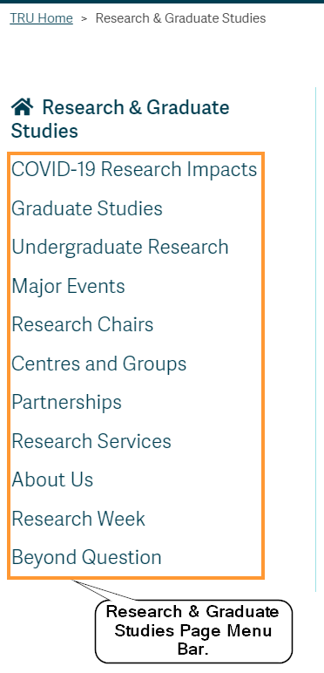

Figure : Research and Graduate Studies Page Menu Bar.

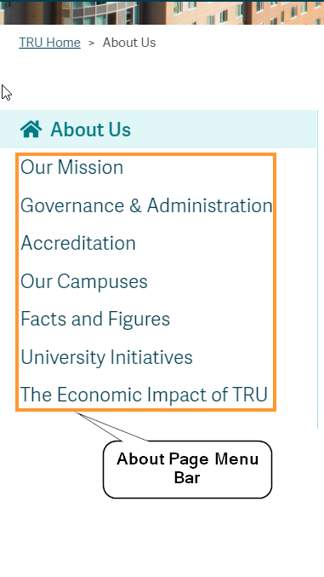

Figure : This is the About Page Menu Bar.